Unit I: Introduction

1.1 Software Engineering Concepts

Participants and Roles in Software Projects

Question
A company in Kathmandu is developing a digital payment system that integrates banks, merchants, and customers. Identify and describe the key roles that contribute to the successful development and deployment of this project.

Definition
Participants are the individual or stakeholders involved in a software project from planning to development, deployment, and use.

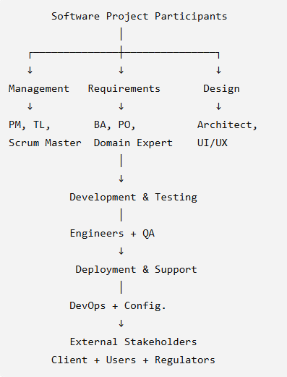

Example:

In Rental Management System developed by a company in Kathmandu:
- Project Manager – manages scope, time, cost, resources and quality.
- Team Leader coordinates developers and assigns development tasks.
- Scrum Master facilitates Scrum activities and removes team obstacles.
- Business Analyst – collects and analyzes requirements.
- Product Owner – prioritizes requirements and product backlog.
- Domain Specialist – provides domain related knowledge.
- System Architect – designs overall architecture and integrations.
- UI/UX Designer designs simple and user-friendly interfaces for customers.
- Software Engineers – develop and integrate system modules.
- QA/Test Engineer – performs functional, security, payment, and domain-related testing.
- DevOps/Operations – handles deployment, CI/CD, monitoring and maintenance.
- Configuration Manager – controls versions and configurations.
- External stakeholders such as clients, end users (landlords and tenants), and regulatory authorities provide requirements, feedback, business objectives, and compliance requirements.

Conclusion
Participants play a vital role in making any software project successful by working together from planning and development to deployment and use while ensuring quality, security, and compliance.

Quick Memory Chain
PM → BA/PO → Architect → Developer → QA → DevOps
↓ ↓ ↓ ↓ ↓ ↓
Plan Need Design Build Test Deploy

### Systems and Models

*(No question and answer provided for this subtopic yet)*

---

### Work Products

Work products are the expected outputs of a software project produced from planning to development, deployment, and use.
---

### Activities, Tasks, and Resources

Activities are the major areas of work performed in a software project from planning and development to deployment and use.
Tasks are the specific actions or steps performed within an activity throughout a software project, from planning and development to deployment and use.
Resources are the people, tools, technologies, materials, time, and budget required to perform activities and tasks throughout a software project, from planning and development to deployment and use.
### Notations, Methods, and Methodologies

Notation | Method | Methodology
How to represent? | How to perform? | How to organize?
UML | OOAD / Interview | Agile / Waterfall
Diagram/model | Procedure/technique | Overall framework

Methodological Approach
Definition:
A methodological approach is a systematic way of solving a problem or conducting software development using defined activities, models, and techniques.
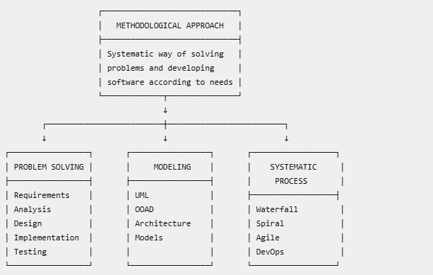
Testing

Explanation
- Problem Solving: Follows a sequence of Requirements → Analysis → Design → Implementation → Testing to develop a software solution.
- Modeling: Uses UML, OOAD, and architectural models as blueprints for understanding and designing the system.
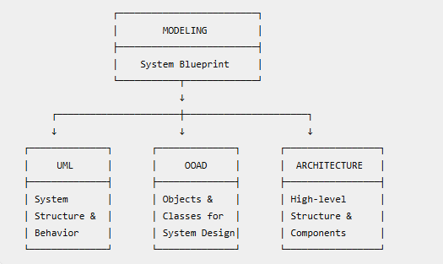
- Systematic Process: Uses methodologies such as Waterfall, Spiral, Agile, and DevOps to organize software development activities.
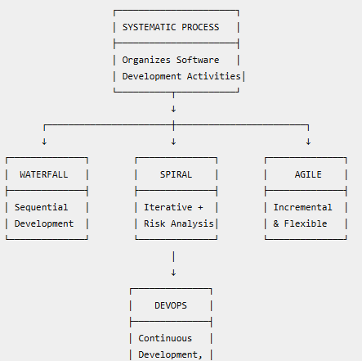

Importance
- Structured Development Process – Organizes the development of the room rent booking system step-by-step.
- Systematic Problem Solving – Solves room search, booking, payment, and cancellation problems systematically.
- Better Planning and Organization – Helps plan requirements, database, user interface, and system features.
- Understanding Complex Systems – Uses UML and models to understand tenants, owners, rooms, and bookings.
- Better Communication – Helps tenants, owners, and developers clearly understand system requirements.
- Improved Software Quality and Management – Supports testing, maintenance, reliability, and effective system management.

Example
In a Room Rent Booking System, developers collect requirements, analyze them, create UML and architectural models, implement the booking functionality, and test the system.

Conclusion
Thus, a methodological approach provides a systematic way of solving problems by following appropriate models and methods according to the requirements.

**Question:**

As Software Engineering is a true engineering discipline? Justify your answer by comparing its methodologies, principles, and professional standards with those of traditional engineering fields.

Software engineering is a systematic, disciplined and quantifiable approach to software development and maintenance. It has many characteristics of traditional engineering.

Problem Solving
Requirements → Analysis → Design → Implementation → Testing
Room Rent Example:
- Requirements: Users need room search and online booking.
- Analysis: Analyze tenant, owner, room, and booking requirements.
- Design: Design database, UML diagrams, and user interface.
- Implementation: Develop the booking system.
- Testing: Test login, room search, booking, and payment.

Modeling
- Uses UML, OOAD, and architectural models as blueprints.
- Room Rent: Use case, class, and sequence diagrams model tenants, owners, rooms, and bookings.

Systematic Process
Uses Waterfall, Spiral, Agile, and DevOps to organize development activities.

2. Engineering Principles

* Understand the problem → Plan → Implement → Examine the result.
* Uses abstraction, modularity, information hiding and separation of concerns.
* Focuses on simplicity, reuse, quality and user value.
Abstraction: Show only important room and booking details.
Modularity: Separate Login, Room Search, Booking, Payment modules.
Information Hiding: Protect user and payment information.
Separation of Concerns: Keep user interface, business logic, and database separate

3. Standards and Professional Ethics
- Uses standards such as IEEE and ISO/IEC 12207 for software processes and quality.
- Follows the ACM/IEEE Software Engineering Code of Ethics.
- Promotes professional responsibility, integrity, and public interest.
Room Rent Example:
- Protect tenant information.
- Maintain accurate booking records.
- Provide secure payment processing.
- Avoid unauthorized access to user data.

4. Differences from Traditional Engineering

Intangible
- Software is logical, not physical.
- Room Rent: The booking system is an application, not a physical product.

No Physical Laws
- Software mainly follows logic and programming rules.
- Room Rent: Booking depends on system rules, not gravity or voltage.

Change-Related Deterioration
- Software does not physically wear out, but frequent changes can increase complexity and reduce quality.
- Room Rent: Frequent changes to booking, payment, and cancellation rules can make the system complex.

Conclusion

Software engineering qualifies as an engineering discipline because it applies systematic methods, engineering principles, standards, measurement, quality control and professional ethics to software development.

Memorization Technique

Remember “M-P-S-D”

* M → Methodology
* P → Principles
* S → Standards & Ethics
* D → Differences

For characteristics, remember:

“Systematic + Disciplined + Quantifiable + Professional”

---

## 1.2 Overview of Software Process Models

### Traditional Models: Waterfall, Iterative, Spiral

Definition
The Waterfall Model is a linear sequential software process model in which development proceeds through predefined phases one after another.

Figure
Requirements
↓
Design
↓
Construction
↓
Testing
↓
Deployment
↓
Support

Main Points
- Requirements – Define customer needs.
- Design – Prepare system architecture and design.
- Construction – Develop the software.
- Testing – Verify and find defects.
- Deployment – Release the software.
- Support – Maintain the system.

Advantages
- Simple and structured.
- Clear phases and documentation.
- Suitable for stable requirements.

Disadvantages
- Difficult to handle changes.
- Working software delivered late.
- Problems may be identified late.

Example
A government system with well-defined and stable requirements can use a sequential development approach.

Conclusion
Waterfall is suitable for stable, well-defined projects, but is less flexible when requirements change.

Iterative

Definition
The Iterative Model develops software through repeated iterations, where each iteration implements additional requirements and produces an increasingly advanced software version.
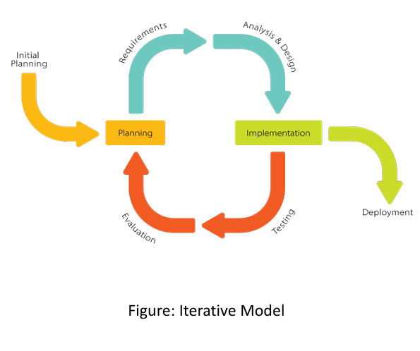

Main Points
- Begin with a small set of requirements.
- Develop the first working version.
- Review the product.
- Identify shortcomings.
- Add or improve features in the next iteration.
- Continue until the expected system is achieved.

Advantages
- Early working software.
- Continuous improvement.
- Supports changing requirements.
- Regular review and feedback.

Disadvantages
- Requires good iteration planning.
- May cause repeated rework.
- Architecture can become difficult to manage if poorly planned.

Example
A Room Rent Booking System can start with room search, then add booking, payment, cancellation, and advanced features.

Conclusion
Iterative development provides successive working versions and allows the system to improve throughout development.

Spiral

Definition
The Spiral Model, proposed by Barry Boehm, is an evolutionary process model combining iterative prototyping with systematic aspects of the Waterfall Model.

Figure
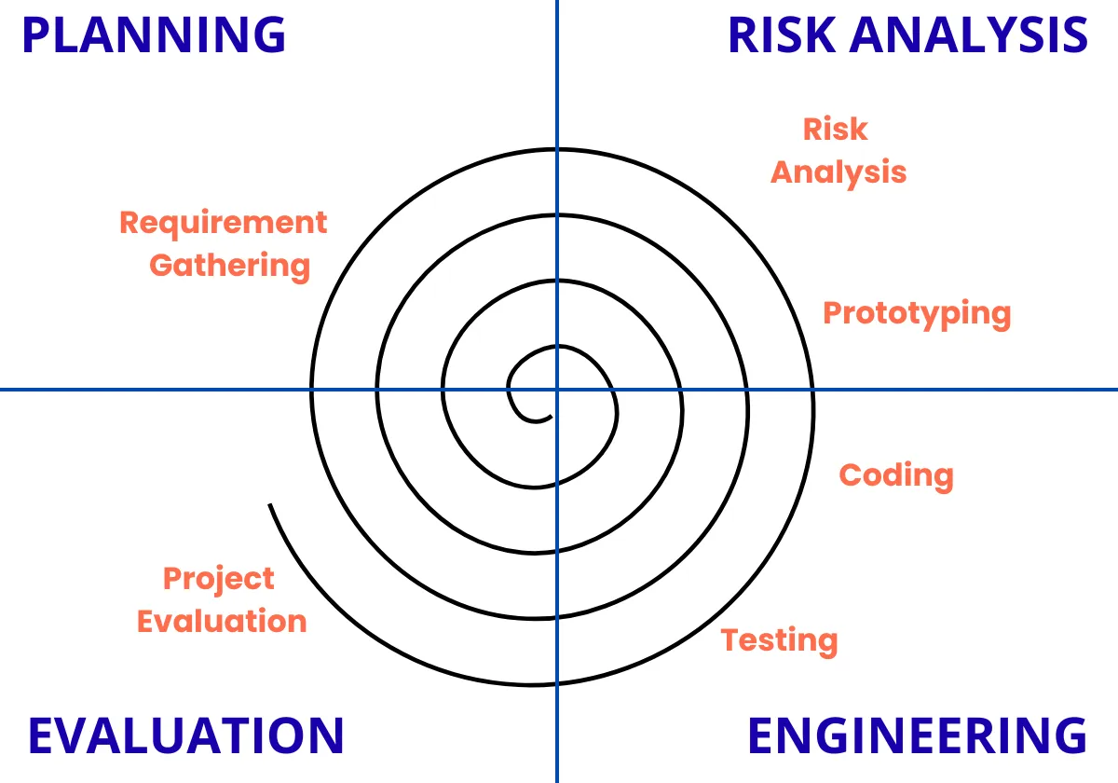

Main Points
- Define objectives, alternatives and constraints.
- Identify and resolve risks.
- Use prototyping when needed.
- Develop and verify the next-level product.
- Evaluate results and feedback.
- Plan the next spiral cycle.

Advantages
- Strong risk management.
- Supports prototyping.
- Handles changing requirements.
- Produces evolutionary releases.

Disadvantages
- Complex to manage.
- Can be costly.
- Requires risk-analysis expertise.
- Less suitable for small, low-risk projects.

Example
For a Room Rent Booking System, one spiral may develop a room-search prototype, the next may add booking/payment, and later spirals may add cancellation and user management.

Conclusion
The Spiral Model is appropriate for complex and high-risk projects because it combines iterative development, prototyping, and systematic risk management.

### Agile Models

Suitable Development Approach: Incremental + Agile

Definition
The Incremental Development Model develops software in small functional increments, with each increment adding new features to the existing system. Agile practices can be used to support frequent delivery and feedback.

Figure
Core Features
↓
Increment 1 → Release
↓
Feedback
↓
Increment 2 → Release
↓
Feedback
↓
Increment 3 → Release
↓
Complete System

Why Suitable?
- Rapid Delivery – Core features can be launched quickly.
- Early User Value – Users can use the platform before all features are complete.
- Changing Requirements – Feedback can guide future increments.
- Reduced Risk – Development and testing occur in smaller increments.
- Continuous Improvement – New features are progressively added.

Example
- Increment 1: Product catalog + checkout
- Increment 2: User accounts + search
- Increment 3: Payment + order tracking
- Increment 4: Reviews + recommendations

Conclusion
The Incremental + Agile approach enables early delivery, progressive enhancement, continuous feedback, and flexibility, making it suitable for an e-commerce platform that needs to launch rapidly and evolve over time.

---

## 1.3 Introduction to Requirements Engineering

### Functional Requirements

*(No question and answer provided for this subtopic yet)*

---

### Non-functional Requirements

*(No question and answer provided for this subtopic yet)*

---

### Importance of Requirements Engineering

*(No question and answer provided for this subtopic yet)*

Unit II: Software Process Models and Project Management

2.1 Agile Development Principles
- Manifesto for Agile Software Development / Benefits of Agile Methodologies
  - Agile process model is replacing traditional models in software development. Illustrate with example, what makes agile suitable compared to the traditional ones. (Fall 2025 PU / PU Central)
JPEG+ 1
  - Explain the core values and principles of the Agile Manifesto. How do they influence software development practices? (Spring 2025 EEC)
PNG
  - What is Agile Manifesto? State its core values. Explain agile scrum methodology highlighting the roles and ceremonies of Scrum. (Spring 2026 EEC)
JPG

2.2 Scrum and Kanban Methodologies
- Scrum Roles, Artifacts, and Ceremonies
  - The Scrum process is widely adopted in modern Agile software development. Explain the various artifacts and ceremonies used in a Scrum-based process. (Fall 2025 EEC)
PNG
  - Explain agile scrum methodology highlighting the roles and ceremonies of Scrum. (Spring 2026 EEC - repeated)
JPG

2.3 DevOps Culture and Principles
- Continuous Integration / Continuous Deployment (CI/CD)
  - Write short notes on: CI/CD (Fall 2025 PU / PU Central)
JPEG+ 1
  - Why do we need DevOps-driven approach for the software development process? Explain CI/CD pipeline in DevOps. (Spring 2026 EEC)
JPG
- Collaboration between Development and Operations
  - A software company is facing frequent delays in product releases due to slow manual testing and poor collaboration between the development and QA teams. The company plans to implement DevOps practices with a focus on test automation, Continuous Integration (CI) using Jenkins, and containerization with Docker. Explain how these DevOps practices can help resolve the issues. What steps should the company take to implement them effectively? (Fall 2025 PU / PU Central)
JPEG+ 1
  - A software company is facing frequent delays in product releases due to slow manual testing and poor collaboration between the development and QA teams. The company plans to implement DevOps practices with a focus on test automation, Continuous Integration (CI) using Jenkins, and containerization with Docker. Explain how these DevOps practices can help resolve the issues. What steps should the company take to implement them effectively? (Spring 2025 EEC - repeated question)
PNG
  - Why do we need DevOps-driven approach for the software development process? Explain the automated tools that contribute in the smooth deployments of the and operation of the software systems. (Fall 2025 EEC)
PNG

2.4 Project Organization Concepts
- Project Organizations and Roles / Task Assignment and Work Products / Scheduling and Time Management
  - Analyze the interplay between project organization (including roles, task assignment, and scheduling) and project communication (such as planned vs. unplanned communication, tools, and meetings) in software project management. How do these elements collectively contribute to the success or failure of a project, and what strategies can be employed to ensure they work jointly to achieve project goals? Provide example to support your analysis. (Fall 2024 PU Central)
JPEG
  - Explain the terms deliverables and milestones in software engineering. (Spring 2026 EEC)
JPG

2.5 Project Communication
- Planned vs. Unplanned Communication / Communication Mechanisms and Tools / Meetings and Reviews
  - Analyze the interplay between project organization and project communication (such as planned vs. unplanned communication, tools, and meetings) in software project management... (Fall 2024 PU Central)
JPEG

2.6 Introduction to DevOps Tools
- Overview of Jenkins, Docker, and Kubernetes
  - What is Docker, and how does it simplify the process of deploying and managing applications in different environments? (Fall 2024 PU Central)
JPEG
  - Discuss the use and importance of Subversion, Jenkins, Docker and Kubernetes in detail. (Fall 2025 PU / PU Central)
JPEG+ 1

Unit III: Requirements Engineering and Elicitation

3.1 Requirements Elicitation Concepts
- Importance of Stakeholder Involvement
  - Why is stakeholder involvement crucial in requirements elicitation? Explain the challenges faced during the requirements gathering process and how they can impact the success of a software project. (Fall 2025 PU / PU Central)
JPEG+ 1
  - Why is stakeholder involvement crucial during the requirements gathering phase of a software project, and what are some common challenges faced in ensuring effective participation from all stakeholders? How can these challenges be addressed to ensure accurate and comprehensive requirements? (Fall 2024 PU Central)
JPEG
  - Why is stakeholder involvement crucial in requirements elicitation? Explain the challenges faced during the requirements gathering process and how they can impact the success of a software project. (Spring 2025 EEC - repeated question)
PNG
  - What are the various phases of requirement Engineering? How requirement elicitation is crucial in requirement engineering? (Fall 2025 EEC)
PNG
- Challenges in Requirements Gathering / Negotiating Specifications
  - A software development company is building a hospital management system. The doctors want a feature that provides a detailed patient history, while the administrative staff wants a simple and quick access system. There is a conflict in their requirements. As a business analyst, how would you handle this situation? What steps would you take to balance stakeholder requirements while ensuring a feasible solution? (Spring 2025 EEC)
PNG

3.3 Elicitation Activities
- Identifying Actors and Stakeholders / Developing Scenarios and Use Cases
  - A software development team is tasked with building an online food delivery platform that allows customers to order food from local restaurants, track their orders in real-time, and make payments online. The platform should also support restaurant owners in managing menus, orders, and delivery schedules, while providing delivery personnel with tools to accept and complete delivery requests.
    - Who are the key actors and stakeholders involved in this system? Provide a list and briefly describe their roles and interests. (Fall 2024 PU Central)
JPEG
    - Create two scenarios, one for a customer placing an order and another for a restaurant owner updating their menu. Based on these scenarios, draft initial use cases for each scenario. (Fall 2024 PU Central)
JPEG
  - Develop a use case description for the Digital Identity Verification System (DVIS). Your answer should include the primary and secondary actors, preconditions, main flow of events, alternative/exception flows, and postconditions. (Fall 2025 PU / PU Central)
JPEG+ 1
  - A digital financial service platform requires users to complete identity verification through a Video KYC process before accessing its services. In this process, a user connects to the system via a live video session, presents identity documents, and interacts with a KYC officer or an automated verification system that performs document validation and liveness detection. Develop a use case description for the Video KYC process. Your answer should include the primary and secondary actors, preconditions, main flow of events, alternative/exception flows, and postconditions. (Fall 2025 EEC)
PNG

Unit IV: Object-Oriented Analysis and Design with UML

4.1 OOAD Principles
- Encapsulation, Abstraction, Inheritance, Polymorphism
  - Explain the terms Encapsulation and Abstraction in the context of software engineering? How these features in OOP contribute in the development of complex real-world application? (Fall 2025 PU / PU Central)
JPEG+ 1
  - Discuss the four fundamental principles of Object-Oriented Analysis and Design (OOAD): Encapsulation, Abstraction, Inheritance, and Polymorphism. Explain how each principle contributes to effective software design, and support your explanation with relevant real-world examples. (Spring 2025 EEC)
PNG
  - Differentiate between OOA and OOD. Explain the core principles in OOAD. (Spring 2026 EEC)
JPG
  - Write short notes on: Encapsulation (Fall 2025 EEC)
PNG
  - What is inheritance? Explain the significance of inheritance of in software development process? (Fall 2025 EEC)
PNG

4.2 Analysis Object Models and Dynamic Models
- Entity, Boundary, and Control Objects
  - A bank wants to develop an online banking system that allows customers to check balances, transfer money, and pay bills. The system should also have an admin panel to manage customer accounts and transactions. Draw a Use Case Diagram for this system and describe the key actors and their roles. Also, explain how Entity, Boundary, and Control Objects can be used in the design process. (Spring 2025 EEC)
PNG

4.3 UML Diagrams & 4.4 Modeling Interactions and Object Lifecycles
- Use Case Diagrams
  - Draw a use case diagram that illustrates the relationships between the actors (e.g., customer, restaurant owner, delivery personnel) and the use cases (e.g., place order, update menu, track delivery). Explain how these relationships ensure the system meets the needs of all stakeholders. (Fall 2024 PU Central)
JPEG
  - A software development team is designing an Online Shopping System where customers can browse products, add items to a cart, and place orders. The system also allows administrators to manage inventory and process orders.
    - Identify the key use cases (e.g., "Add to Cart," "Place Order") and map them to the objects involved (e.g., Customer, Product, Cart, Order). (Fall 2024 PU Central)
JPEG
  - Differentiate between include and extend relationship in use-case diagram. Identify the use-cases, actors and relationships and finally draw use case diagram for following system: An organization has an employee attendance system that uses face recognition mechanism to automatically identify employees when they enter the workplace... (Spring 2026 EEC)
JPG
- Class Diagrams / Associations, Aggregations, Inheritance
  - Create a class diagram showing the relationships between objects, such as how a Customer associates with a Cart and how a Cart aggregates Product objects. (Fall 2024 PU Central)
JPEG
  - Identify any inheritance relationships, such as different types of users (e.g., Customer and Admin inheriting from a User class). (Fall 2024 PU Central)
JPEG
  - Explain how these modeling techniques help in understanding the behavior and structure of the Online Shopping System. Provide examples to illustrate your answer. (Fall 2024 PU Central)
JPEG
- Sequence Diagrams
  - Using the Library Management System scenario, analyze how class diagrams and sequence diagrams can be used to model the system's structure and behavior. How do these diagrams help in understanding the relationships between classes and the flow of interactions during key processes like borrowing a book? What challenges might arise when creating these diagrams, and how can they be resolved to ensure accurate system design? (Fall 2024 PU Central)
JPEG
- Activity Diagrams
  - What is the use of swimlanes in activity diagram? Also explain the application of fork and join in activity diagram. Create activity diagram for Mobile Top-up via mobile banking application. (Spring 2026 EEC)
JPG

Unit V: Design Patterns and Reuse

5.1 Reuse Concepts
- Specification vs. Implementation Inheritance / Delegation / Liskov Substitution Principle
  - Compare and contrast Specification Inheritance and Implementation Inheritance. Provide examples to illustrate their applications and explain how Delegation and the Liskov Substitution Principle relate to these concepts. (Spring 2025 EEC)
PNG

5.2 Common Design Patterns
- Creational Patterns: Factory, Abstract Factory
  - Explain the creational design pattern with an example. (Fall 2025 PU / PU Central)
JPEG+ 1
  - Differentiate between design pattern and framework. Explain factory pattern and abstract factory pattern. (Spring 2026 EEC)
JPG
- Structural Patterns: Adapter, Composite, Bridge
  - Write short notes on: Composite Pattern (Spring 2025 EEC)
PNG
- Design Patterns Overview / Selection
  - What is a design pattern? How design pattern supports in reusability? (Fall 2025 PU / PU Central)
JPEG+ 1
  - What is a design pattern in software? Explain any two design patterns. (Fall 2025 EEC)
PNG

Unit VI: Software Quality Assurance and Testing

6.2 Software Cost Estimation
- COCOMO Model
  - Write short notes on: COCOMO Model (software engineering part 2)
JPG

6.3 Software Quality Assurance Planning and Process
- Quality Assurance Activities
  - Describe the different QA activities and their significance. (Fall 2025 PU / PU Central)
JPEG+ 1
  - Write short notes on: Formal Technical Review (FTR) (Spring 2025 EEC)
PNG
  - What do you understand by Formal Technical Review (FTR)? Explain different activities during a FTR meeting. (Spring 2026 EEC)
JPG

6.4 Testing Concepts
- Faults, Erroneous States, and Failures
  - Differentiate Faults, Erroneous States and Failures with example. (Fall 2025 PU / PU Central)
JPEG+ 1
- Test Cases, Test Stubs, and Drivers
  - Describe the Test Stub and Test driver. Why and how integration testing is carried out? Explain. (Fall 2025 PU / PU Central)
JPEG+ 1
  - Write short notes on: Test Cases, Test Stubs, and Drivers (Spring 2025 EEC)
PNG

6.5 Testing Activities
- Unit Testing / Integration Testing / System Testing
  - Write short notes on: Unit Testing (Fall 2025 EEC)
PNG
  - Why and how integration testing is carried out? Explain. (Fall 2025 PU / PU Central)
JPEG+ 1
- Black-Box Testing and White-Box Testing
  - What are different types of software testing. Explain the black-box testing and white-box testing. (Fall 2025 EEC)
PNG
  - Why is software testing essential in the software development life cycle? Describe how software testing is carried out, and explain various types of testing approaches with examples, based on different needs and purposes. (Spring 2025 EEC)
PNG
  - How is white-box testing different from black-box testing? Explain with example. Explain various techniques for black-box testing. (software engineering part 2)
JPG

Unit VII: Configuration Management and DevOps Tools

7.1 Configuration Management Planning
- Configuration Items and Baselines (CSCI)
  - What is a software configuration item (SCI)? How are configuration items managed throughout the software development lifecycle? Explain the importance and key objectives of configuration management in software engineering. (Spring 2025 EEC)
PNG
  - What do you understand by CSCIs in Software Configuration Management? Explain SCM with its major activities. (software engineering part 2)
JPG

7.2 Change Management
- Managing Change Requests / Version and Release Management
  - Explain the process of incorporating change in development process. How has CASE tools changed the process of version and release management in present context? Discuss in brief. (Fall 2025 PU / PU Central)
JPEG+ 1
  - What is Change Management in software development? Explain the key steps involved in managing change requests, and discuss how version and release management ensure software stability. (Fall 2025 EEC)
PNG

7.4 CASE Tools for Configuration Management
- Overview of CASE / SCM Tools
  - Write short notes on: CASE Tools for Configuration Management (Fall 2025 EEC)
PNG
  - Discuss the use and importance of Subversion, Jenkins, Docker and Kubernetes in detail. (Fall 2025 PU / PU Central)
JPEG+ 1

Unit VIII: Emerging Trends in Software Engineering

8.1.1 Cloud-Native Development & Serverless Computing
- Cloud-Native Development
  - Cloud Native Development has largely impacted the development process. Discuss how? (Fall 2025 PU / PU Central)
JPEG+ 1
  - What are the advantages of cloud-native development? Explain some secure software development practices. (software engineering part 2)
JPG
- Serverless Computing
  - Write short notes on: Serverless Computing (Fall 2025 PU / PU Central)
JPEG+ 1

8.1.2 AI in Software Engineering
- AI-Assisted Coding and Testing
  - Discuss the role of AI in Software Engineering. How do AI-assisted coding and testing tools improve development processes? Provide examples of tools and their impact. (Fall 2025 EEC)
PNG
  - Discuss the role of AI in Software Engineering. How do AI-assisted coding and testing tools improve development processes? Provide examples of tools and their impact. (Spring 2025 EEC - repeated question)
PNG
  - Write short notes on: AI in Software Engineering (Spring 2025 EEC)
PNG

8.1.4 Sustainability in Software Engineering
- Eco-Friendly Practices / Sustainable Resource Usage
  - Sustainability and Environment Concerns are impacting the field of IT, How? What considerations do we need to make while deploying software solutions in current context? Discuss. (Fall 2025 PU / PU Central)
JPEG+ 1

8.1.5 Secure Software Development Practices
- Principles of Secure Code & Prevention
  - What are the advantages of cloud-native development? Explain some secure software development practices. (software engineering part 2)
JPG

Miscellaneous / Supplementary Topics
(Out-of-syllabus topics that appeared in historical question papers)
- Software Re-engineering
  - Write short notes on: Software Re-engineering (software engineering part 2)
JPG
- Coupling and Cohesion
  - Write short notes on: Coupling and Cohesion (software engineering part 2)
JPG

